VII Lecture: Immunopathology. Immunodeficiency. Reactions of hypersensitivity. The vaccine and antiserum. Immunotherapy and immunoprevention.
The purpose of the lecture:
To inform students about immunopathology, primary and secondary immune deficiencies, hypersensitivity reactions (allergic reactions), their application in microbiological diagnostics. To introduction students with the principles of immunoprophylaxis and immunotherapy. Provide information about vaccines and serums, types,their purchase and application.
Lecture plan:
- Information on the pathology of the immune system: hypersensitivity and immunodeficiency.
- Immune deficiencies:
-congenital (primary)
- acquired (secondary).
2. Introduction immune deficiencies:
-Deficiency of B-lymphocytes.
-T-lymphocyte deficiency (introduction immune deficiency syndrome).
3. Hypersensitivity reactions ( allergens)/ classification of hypersensitivity reactions :
-Type I(anaphylactic type) hypersensitivity reaction: anaphylaxis,atopy, drug allergy.
-Type II (cytotoxic) hypersensitivity reactions.
-Type III (immune complex) hypersensitivity reactions. Arthurian phenomenon, serum sickness.
-Type IV (delayed) hypersensitivity reactions. Infectious allergies, contact allergies, drug allergies.
- Autoimmune reaction and diseases.
- Immunodiagnostic and serological reactions and their types. Principles of immunoprophylaxis.
- Vaccines:
-live vaccines.
-inactivated (killed) vaccines.
-molecular vaccines (protective antigen).
-anatoxins (toxoids).
-synthetic vaccines (chemically or biologically synthesized antigen).
-recombinant vaccines.
- Associative vaccines.
- Adjuvants.
- Principles of immunotherapy.
- Immune serums (antitoxic, antibacterial, antiviral serums), acquisition and application.
- Diagnostic immune serums.

Lecture equipment: Computer, projector, electronic slides related to the lecture
Literature: p.1

Immunopathology is a branch of medicine that deals with immune responses associated with disease. It includes the study of the pathology of an organism, organ system, or disease with respect to the immune system, immunity, and immune responses. It refers to damage caused to an organism by its own immune response, as a result of an infection. It could be due to mismatch between pathogen and host species, and often occurs when an animal pathogen infects a human (e.g. avian flu leads to a cytokine storm which contributes to the increased mortality rate).
When a foreign antigen enters the body, there is either an antigen specific or nonspecific response to it. These responses are the immune system fighting off the foreign antigens, whether they are deadly or not. Immunopathology could refer to how the foreign antigens cause the immune system to have a response or problems that can arise from an organism's own immune response on itself. There are certain problems or faults in the immune system that can lead to more serious illness or disease. These diseases can come from one of the following problems. The first would be Hypersensitivity reactions, where there would be a stronger immune response than normal. There are four different types (type one, two, three and four), all with varying types and degrees of an immune response. The problems that arise from each type vary from small allergic reactions to more serious illnesses such as tuberculosis or arthritis. The second kind of complication in the immune system is Autoimmunity, where the immune system would attack itself rather than the antigen. Inflammation is a prime example of autoimmunity, as the immune cells used are self-reactive. A few examples of autoimmune diseases are Type 1 diabetes, Addison's disease and Celiac disease. The third and final type of complication with the immune system is Immunodeficiency, where the immune system lacks the ability to fight off a certain disease. The immune system's ability to combat it is either hindered or completely absent. The two types are Primary Immunodeficiency, where the immune system is either missing a key component or does not function properly, and Secondary Immunodeficiency, where disease is obtained from an outside source, like radiation or heat, and therefore cannot function properly. Diseases that can cause immunodeficiency include HIV, AIDS and leukemia.

Immune deficiencies can be congenital and acquired. Immune deficiency in any of the 4 main components that make up the immune system: 1. B-lymphocyte system (antibodies), 2. T-lymphocyte system, 3. complement system, 4. it can develop as a result of disorders occurring in phagocytes. Clinically, opportunistic or recurrent infections are more typical at this time. Recurrent infections caused by pyogenic bacteria, mainly B-lymphocyte deficiency, recurrent fungal, viral, or protozoan infections are typical for T-cell deficiency.
Autoimmune diseases
In the elderly, tolerance is usually observed against antigens that have been exposed during the embryonic period and are known as "native". In some cases, tolerance is lost and an immune response is formed by the immune system against the body's own antigens, in other words, an autoimmune disease is formed. In the pathogenesis of autoimmune diseases, the interaction of the components of the immune system with their own healthy cells and seeds is stopped. Autoimmune diseases are sometimes referred to as immune complex diseases. Many diseases whose pathogenesis is based on autoimmune processes are known (autoimmune thyroiditis, glomerulonephritis, rheumatoid arthritis, systemic lupus erythematosus (SLE) etc.).

Hypersensitivity reactions
When the immune response results in unusual, dangerous reactions for the body, the terms hypersensitivity (in English, hypersensitivity) or allergy (lat., allos-foreign, ergone-effect) are used. The clinical manifestation of these reactions is typical and characteristic in different individuals and occurs in individuals with high sensitivity to these antigens as a result of contact with specific antigens. As a result of the first contact of an individual with an antigen, sensitization occurs, and then repeated contacts with the same antigen cause the formation of allergic reactions. Hypersensitivity reactions are divided into 4 types. Types I, II and III are activated by antibodies (B-lymphocytes). Type I reactions are related to IgE, and type II and III reactions are related to IgG. Type IV reactions are related to sensitized T-lymphocytes.
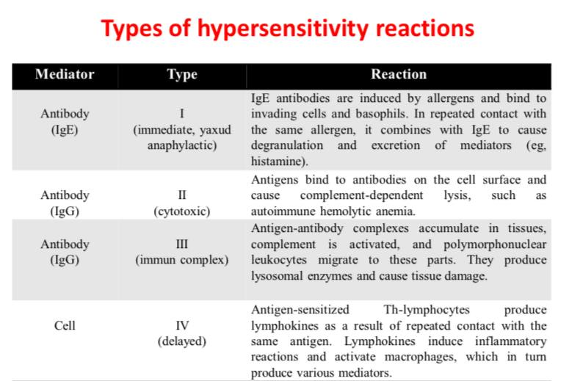

Type I (anaphylactic type) hypersensitivity reactions
An immediate hypersensitivity reaction occurs under the influence of a number of mediators released as a result of the combination of antigen with IgE on the surface of cells. The process is formed as a result of the induction of IgE antibodies by the antigen and their binding to the surface of basophils and immune cells through the Fc fragment. This situation is called sensitization. Repeated contact with the same antigen and its combination with IgE on the surface of basophilic or immune cells results in the release of biologically active mediators from these cells within 1 minute (immediate reaction). Clinical signs of type I sensitivity are in various forms, for example, atopy, allergic rhinitis, or Quincke's edema, allergic eczema, allergic rhinitis, allergic conjunctivitis, or hay fever, allergic asthma, etc. who can manifest. However, the most severe form of sudden type hypersensitivity manifests as anaphylaxis. At this time, severe bronchospasm and hypotension (shock) can be life-threatening.
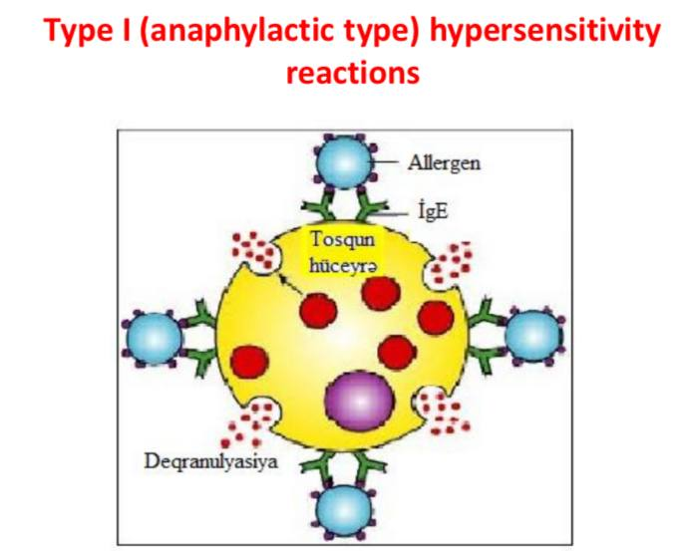

Desensitization : It has been determined that the introduction of small doses of allergens into the body results in the weakening or loss of hypersensitivity. Since the antigen-IgE complex is formed in a small amount at this time, not enough mediators are produced for the formation of strong allergic reactions. This situation, which is the opposite of sensitization, is called desensitization. It is possible to prevent systemic anaphylaxis through it. This method (Bezredko method) allows to prevent allergic reactions during the use of some medicines, especially immune serums.

Type II (cytotoxic type) hypersensitivity reactions
Cytotoxic type hypersensitivity occurs as a result of the combination of antibodies formed against cell membrane antigen with this antigen and activation of complement. The antibody (IgG) binds to the antigen through the Fab-fragment, and to the complement through the Fc-fragment. This leads to the production of the complement membrane binding complex and damage to the cell membrane. As a result, hemolytic anemia-type complement-mediated lysis occurs, as in blood transfusion reactions incompatible with the ABO system or the Rhesus factor.
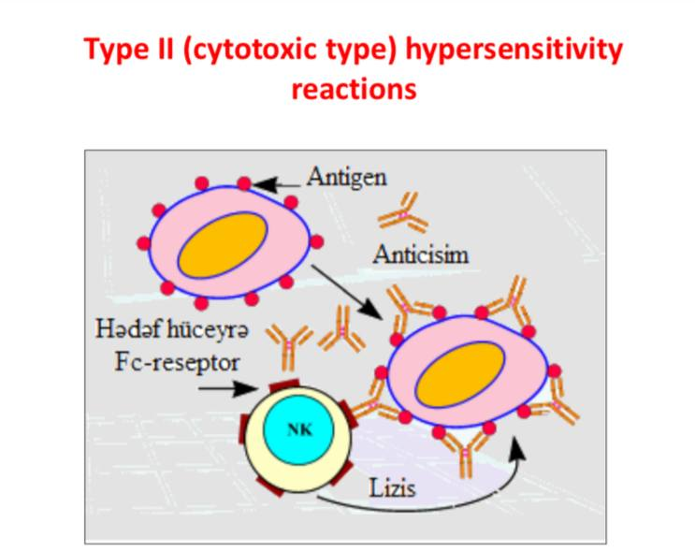

Type III (immune complex type) hypersensitivity reactions
Immune complex-type hypersensitivity is characterized by antigen-antibody complexes causing inflammatory processesin tissues. Normally, immune complexes are removed from the body through the reticuloendothelial system, but sometimes they are retained in the body and cause a number of diseasesin the tissues. In persistent bacterial and viral infections, immune complexes can accumulate in organs, such as the kidney, causing damage. In autoimmune disorders, "native" antigens (autoantigens) can induce the synthesis of autoantibodies. It is observed that the latter combine with the relevant antigens, or form deposits as complexes in organs, especially joints (arthritis), kidneys (nephritis) or blood vessels (vasculitis). Deposition of immune complexes in tissues, for example, on the wall of blood vessels, activation of the complement system and chemotaxis of neutrophils to these parts is accompanied by inflammation and tissue damage (e.g., vasculitis). Type III hypersensitivity reactions include Arthus phenomenon and serum sickness.
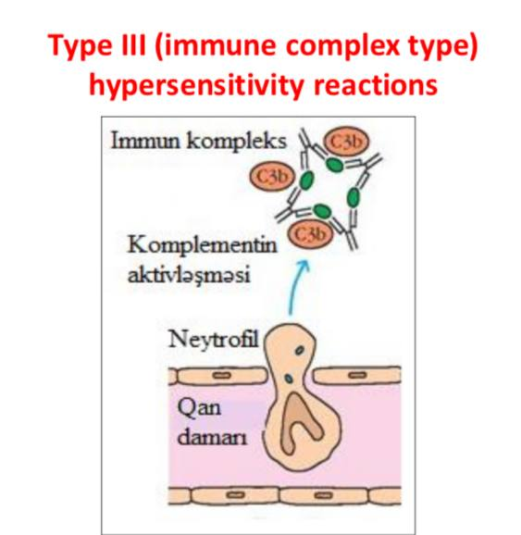
Type IV (delayed type) hypersensitivity reactions
Delayed-type hypersensitivity (DTH) reactions are associated with T-helpers (CD4) and cytotoxic T-lymphocytes. DTH is a lymphoid-macrophage reaction and develops as a result of immune activation of macrophages by the effect of lymphocytes sensitized by allergen. Immune inflammation mechanisms are based on DTH: the antigen enters the body, undergoes phagocytosis by macrophages, breaks into small parts, and its fragments appear on the surface of macrophages in association with class II MHC. Antigen-II class MHC complex interacts with antigen-specific receptors on the surface of Thlymphocytes. Th-lymphocyte activation and clonal proliferation occur due to IL1 produced by macrophages and IL2 synthesized by lymphocytes.
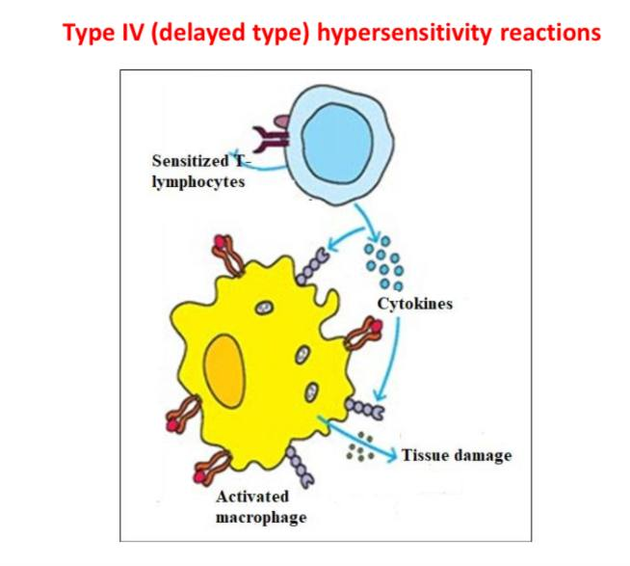
Allergological diagnostic methods
Due to the activation of cellular immunity in many infectious diseases, a state of high sensitivity to pathogens and their toxins develops. Allergic tests used in the diagnosis of infectious diseases are based on this phenomenon. Allergy tests allow to reveal the state of high sensitivity in the body. Allergens are used for this purpose. Allergens used in the diagnosis of infectious diseases consist of the filtrate of the purified broth culture of the respective microorganisms, and sometimes from killed microorganisms or antigens prepared from them. Allergy tests are specific, but these reactions also give positive results in people who have had the disease or who have been vaccinated. Allergic tests used in immunodiagnostics are divided into two groups: in vivo and in vitro. In vivo allergic tests include skin-allergic tests. These tests are performed on directly examined patients, and allow to detect immediate and delayed hypersensitivity (ITH and DTH).
Skin-allergic tests
Allergens are usually injected intradermally or rubbed onto the scarified skin surface. In the intradermal method, an amount of 0.1 ml of the allergen is injected into the skin of the front surface of the skin by means of a special needle. When the reaction is positive, after 24-48 hours, a papule (redness and swelling) is formed at the place where the allergen was injected (DTH). By measuring the diameter of the papule, a conclusion is made about the intensity of the reaction. Allergens of non-microbial origin (plant pollen, household dust, etc.) are mainly injected by rubbing on the scarified skin surface, or intradermally, as well as by means of an injection (prick test) passing through an allergen drop placed on the skin surface. The result of the reaction is evaluated after 20 minutes (ATH) and 24-48 hours (DTH). Determination of DTH by means of a skin-allergic test can be used to determine tuberculosis (Mantu test), brucellosis (Burne test), leprosy (Mitsuda test), tularemia, actinomycosis, etc. used in the diagnosis of diseases.

Immunoprevention and immunotherapy are aimed at the formation of active or passive immunity against the causative agent by forming insensitivity to their causative agents in order to prevent infectious diseases. Active or passive immunity is induced in the body as a result of immunization to protect against infectious diseases. 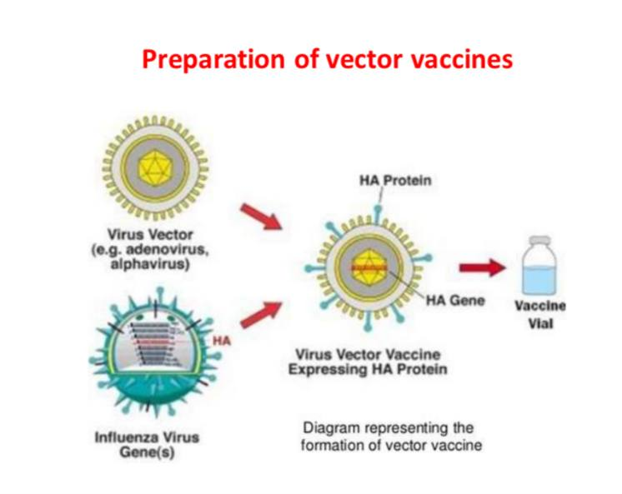

Vaccines

Active immunity is formed as a result of immunization with vaccines. Vaccines are prepared from microorganisms or their antigens, their injection into the body causes the formation of artificially acquired immunity against the disease.
Inactivated (killed) vaccines : Chemical substances (for example, phenol, formaldehyde), high temperature, etc. it consists of microorganisms that have lost their ability to live due to its influence and have been killed. To obtain inactivated vaccines, pathogenic microorganisms are cultivated in artificial nutrient media, then they are inactivated, purified, and obtain a liquid or lyophilized preparation.
Live (attenuated) vaccines: It is prepared from the appropriate microorganism strains whose virulence is weakened. These vaccines consist of genetically modified microorganisms that have lost the ability to cause disease, but have acquired, retained the ability to form specific anti-infective immunity (BCG vaccine, rabies, measles vaccine, etc.). Currently, recombinant DNA technology is used to obtain attenuated vaccine strains. To prepare virus vaccines, the genes responsible for the synthesis of their antigens are transferred to vectors, for example, smallpox viruses with large DNA content. Such vaccines are called vector vaccines.
Chemical vaccines : It is obtained by disintegration of microbial cells, consisting of separate components(antigens) of microbial cells. Recently, these vaccines are obtained through genetic engineering, they are called recombinant vaccines. For this, recombinant yeast strains are created by transferring the genes that ensure the synthesis of the immunodominant antigen of any microorganism to the producer cells, for example, to the cells of yeast fungi. As the resulting recombinant yeast cells have the genes that will ensure the synthesis of a certain antigen, they synthesize the appropriate antigen substance. Currently, a vaccine prepared from the virus antigen (HBs-antigen) synthesized by recombinant yeast strainsis used in the specific prophylaxis of hepatitis B.
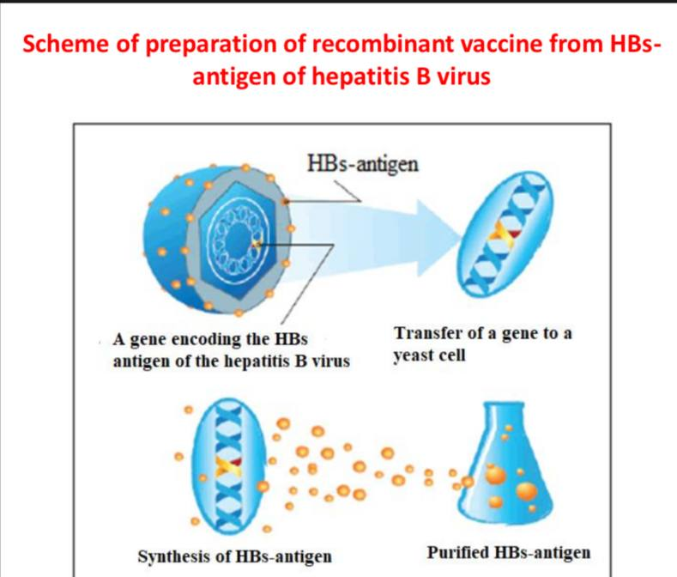

Synthetic vaccines : The preparation of synthetic vaccines is based on the use of the artificially synthesized immunodominant antigen (protective antigen) of the diseasecausing microorganism. For this, the amino acid sequence of the immunodominant antigen is studied and synthesized, the resulting protective antigen can theoretically be used as a vaccine. However, synthetic peptides are weak antigens, and to increase immunogenicity, it is necessary to combine them with a carrier protein or a synthetic biopolymer (muramyl peptide, D-glutamine copolymers, etc.). Automatic synthesizers are used to produce such vaccines. So far, efforts to use a synthetic vaccine against foot-and-mouth disease have been unsuccessful. This vaccine has been tested in guinea pigs, pigs and cattle. Although the vaccine protected against the disease, the antibody response induced by it was 10-100 times weaker than immunization with whole virions. This vaccine has not found wide practical application.
Anatoxins or toxoid vaccines: Some vaccines contain toxoids instead of microorganisms, which do not cause disease, but have the ability to induce an immune response. Exotoxins lose their toxicity in 3-4 weeks under the influence of 0.4% formaldehyde at 37°C, but are transformed into anatotoxin (toxin) while keeping their specific antigenicity. 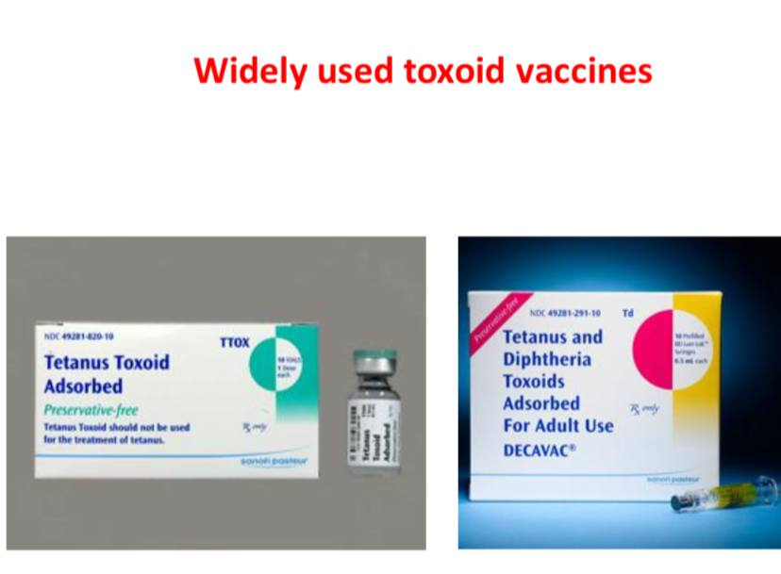
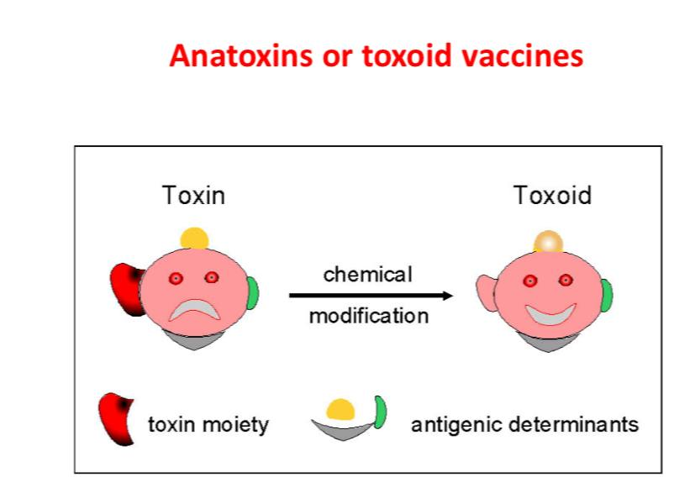

Adjuvant (helper) - complex substances used to increase the immune response when administered simultaneously with an immunogen. Unlike immunomodulators, they are used to increase a certain immune response in the body (for example, during vaccination) and to normalize a weakened immune response. Most adjuvants by adsorbing antigens on their surface create a depot and ensure their long-term storage in the body, which increases the duration of the effect on the immune system. Adjuvants can be inorganic (aluminum and calcium phosphates, calcium chloride, etc.) and organic (agar, glycerol, protamines, etc.). Currently, the following adjuvants are more commonly used: - Freund's incomplete adjuvant. It is a water-in-oil emulsion containing petroleum jelly, lanolin and an emulsifier. By storing the antigen, it enhances its capture by phagocytes. - Freund's Complete Adjuvant. The above components include BCG or muramyl dipeptide. This allows activation of macrophages and costimulation of T-cells. - Aluminum hydroxide - Al (OH)3 stores antigens due to its high sorption capacity and enhances phagocytosis.
Vaccination : It is carried out according to planned and epidemiological instructions. Each country has a preventive vaccination calendar and control over the planned preventive vaccinations. Mandatory administration of such vaccinations is regulated by legislation.
Immune serums : In order to form passive immunity in immunoprevention and immunotherapy, preparations containing antibodies against the relevant causative agent or its toxin are used - immune serum and immunoglobulins. The mechanism of action of the immune serums used for these purposes is related to the neutralization of the specific antibodies in their composition against the corresponding microorganisms and their toxins. Immune serum and immunoglobulins are used for two purposes: for prevention (seroprevention) and for treatment (serotherapy). In order to receive immune sera, mainly large animals, for example, horses, are hyperimmunized with microorganisms or their antigens. Then, after cleaning the blood serum of such animals from ballast substances, it is used as an immune serum. In some cases, the serum of people who have had a disease, or the blood serum of specially immunized donors, as well as placental blood serum, are used as immune serum. Immune serums are especially used for the treatment of toxinemic infections (tetanus, botulism, diphtheria, gas gangrene), as well as some bacterial and viral infections (measles, measles, plague, anthrax, etc.). The prophylactic dose of these drugs is significantly less than the treatment dose. To create passive immunity, the drug is usually administered intramuscularly to people who have been in contact with patients or other sources of infection. Immunity is formed quickly and usually lasts up to a month. After this period, the immunity disappears as the antibodies are removed from the body. Diagnostic immune serum are used to identify microorganisms in various serological reactions. These sera are usually obtained by hyperimmunizing small animals, such as rabbits, with microorganisms or their antigens. Blood serum of laboratory animals (mainly rabbits) hyperimmunized with appropriate antigens is used as diagnostic immune serum, which contains specific antibodies in high titers.

